NoSQL

- Before we can truly understand a database service like DynamoDB, we need to understand NoSQL, which is a type of database that doesn't rely on the traditional relational table structure of SQL.
  - While traditional SQL’s data is organized into strict tables and relationships enforced through PKs/FKs, NoSQL breaks away from that relational philosophy by storing data in more flexible formats.
    - These formats include key-value pairs, documents, and graphs. As we’ll see, some NoSQL tools let you work with multiple formats.

“When should we use NoSQL vs SQL??” you all shout in unison

- Use NoSQL when:
  - You need to scale massively and quickly,
  - Your data doesn't fit neatly into rows/columns.
  - Or your app needs really fast read/write performance for simple operations

- Stick with regular SQL when:
  - You need strong relationships between data,
  - You want to run complex queries across multiple tables,
  - Or you need strict data integrity enforced by a concrete schema.

Ok so what is DynamoDB?

- DynamoDB is a NoSQL key-value and document database that’s designed to be fast, predictable, and scalable. It's also fully managed, which is nice.
  - Remember if a service is “managed”, that means AWS handles the underlying infrastructure for you. You don't have to manage anything yourself. Note that this convenience often comes with a higher price.
    - “Underlying Infrastructure” can be things like servers, scaling behavior, patches, backups.

- Companies use DynamoDB to handle read/write operations reliably under unpredictable or heavy traffic. Having quick, reliable DB ops is one of the most important things for a company that needs to process a ton of data fast.
  - Imagine the cart feature of an ecommerce website stalling or breaking due to heavy traffic during the holiday season. That’s a ton of money lost and the shareholders won’t be able to afford their second yacht :((((((((
    - This is the kind of stuff DynamoDB helps us avoid.

The data in Key-Value Document Databases doesn’t look TOO different from what we’re used to, but the structure is more flexible and nested than what you'd see in a SQL table. Instead of rigid rows and columns, each item can have its own unique fields.

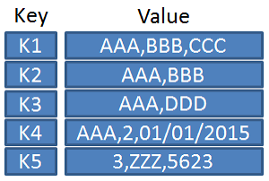

Tables, Items, and Attributes

- These are 3 key concepts that comprise how data is organized in DynamoDB.

- Tables are containers for your data. Similar to a SQL table, but without a fixed schema (cuz remember we’re using a Document Database). Different items in the same table can have completely different attributes.

Here’s a table of movies:
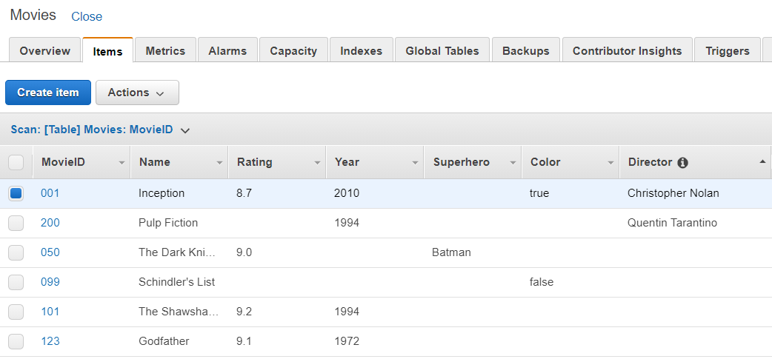
Note how some of these items have fields that other items would never have

- Items are individual records within a table. Similar to a row in SQL. Items are what you actually Create, Read, Update, and Delete in DynamoDB (the CRUD operations!
  - Items are pretty much directly analogous to SQL records. Easy enough.

- Attributes are the individual pieces of data within an item. Similar to a column in SQL.
  - The key difference is that unlike SQL columns, attributes don't have to be consistent across items. One item could have 3 attributes, the next could have 10.
    - Again, this is a NoSQL discipline. We don’t have a rigid schema enforcing uniformity like in a RDBMS.

Partition Keys and Sort Keys

- Every item in a DynamoDB table needs a primary key, and there are two main types you can use. These coexist in one table if you choose to have both.

Partition Keys (required)

- A single attribute that uniquely identifies an item. Like user_id or zoo_animal_id, etc. DynamoDB uses this to determine which physical partition the item lives on. Items with the same partition key live together, which helps DynamoDB route queries efficiently. Instead of searching the entire table, it goes straight to the right partition.
  - BTW a “Physical partition” is basically just the storage location. Where the item lives in the DB. DynamoDB has multiple partitions for storing and distributing data, and it’s all handled under the hood by AWS.

Sort Keys (optional)

- A second attribute that combines with the partition key to help make items unique. Sort keys let you store multiple related items under the same partition key and retrieve them in a sorted, filterable way.
  - This is also how we store items in a particular order! Storage is NOT based on the partition key.

So for example, an orders table might have user_id as the partition key and order_date as the sort key. One user can have many orders, all grouped together and sorted by date.

Querying DynamoDB

- DynamoDB is not a SQL database so DBeaver doesn't really apply here. There's no SQL query editor experience or anything. But we can use the AWS Console pretty easily to query your data after setting it up.

The console looks like this (the AWS sandbox may look a little different):
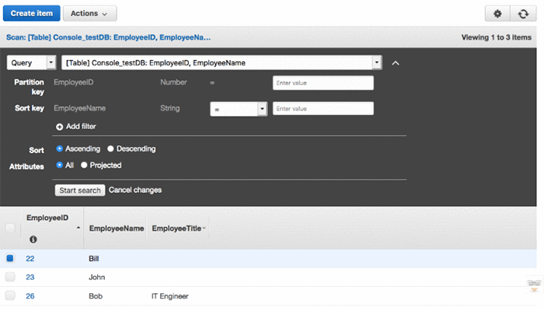

- This brings us to the concept of query filtering vs scan filtering. These are two ways to retrieve data from a DynamoDB table.

  - Query Filtering uses the partition key to go directly to the right partition and retrieves only the items you're looking for. Fast, targeted, and what you should default to.
    - This is the more efficient but restrictive approach.

  - Scan Filtering reads every single item in the entire table and filters after the fact. Functionally it works, but it's slow and expensive at scale. Use it sparingly, like in little admin tasks or small tables where performance doesn't matter.
    - This is the more brute force but flexible approach

- You can choose between query/scan when you select data in the AWS Console. They’re both available as explicit operations with their own dedicated tabs. But defaulting to scan filtering on a large table is a good way to burn through your read capacity fast.

DynamoDB Setup (Pretty painless in my limited experience)
- Search for DynamoDB in the AWS Console then “Create Table”
- Give your table a name and define your Partition Key (and optionally a Sort Key). This is the most important step, and also depends pretty heavily on what exactly you’re doing
  - I’ll put something cohort-specific here when we actually can in the sandbox
- Leave capacity on On-Demand mode. DynamoDB scales automatically which is good for cost optimization, but also potentially scary.
- Click Create Table and it’ll be ready almost instantly. Not every AWS service gives you this luxury.
- Insert some data and query it!
NOTE: DynamoDB has a pretty generous free tier, which is 25GB of storage and 25 read/write capacity units per month. The stuff we’re doing in the Sandbox shouldn’t get anywhere near that.

Converting Relational Schemas into DynamoDB Schemas

- This is just an overview of the process and considerations. It would be a bit of a pain to actually implement, and not worth it imo. I guess FNMA wants you to have some background on this in case some of you Data Analysis people end up doing migration work etc.

- Identify access patterns
  - Unlike SQL where you model data then run queries, DynamoDB starts with queries and models data around them. So you need to consider what kinds of queries you’ll be making (the “patterns” of “access”).

- Identify your partition key
  - What's the most common way you'll look things up? That becomes your partition key. Pretty similar to the SQL Primary Keys we worked with.
    - Examples from Claude:
      - For a user's cart: user_id.
      - For order history: user_id with order_date as sort key.

- Denormalize your data
  - Instead of splitting related data across tables and doing stuff like joins, you embed it together in one item. Again, we’re in NoSQL, so you don’t actually want Normalization. A cart item might contain product name, price, and quantity all in one place.

- Accept some redundancy
  - This is the one that feels especially weird to me. Data will be duplicated across items sometimes. That's intentional and fine in NoSQL workflows. You're trading storage efficiency for speed and scalability.
    - Are we worried about data integrity? Less than in SQL as far as I’ve seen, but that tradeoff is intentional. NoSQL always prioritizes speed and scalability over the integrity that relational DBs guarantee. You're trusting your application layer (the backend usually) to handle data consistency.

- One table design
  - This one is weird to me too. DynamoDB often puts everything in a single table with carefully chosen keys rather than making multiple tables like in SQL. We won't go that deep, it's a thing you'll encounter if FNMA has you working in Dynamo.

